The

GSystems

Graphic

Control

Copyright/Disclaimer

This Document and the software described herein are protected under Copyright by InnoVisioNate Inc.
To the maximum extent permitted by applicable law, InnoVisioNate Inc. shall not be held liable for any damages; whether they be consequential, incidental, indirect, special, or of any other type, whatsoever. These may include but are not limited to; damages for loss of business profits, business interruption, loss of business information, or any other pecuniary loss arising out of the use of, or inability to use, this product.

Contents
Glossary iii
About the GSystems Graphic Control iv
About the Company iv
About this Document v
Notational Convention v
Part 0… vi
Part I… vi
Part II… vi
Part III… vi
Part IV vi
Part V vi
Part VI vi
Part VII vi
Overall… vi
Part 0 – Who uses the GSystems Graphic Control and where? 1
Can I redistribute the GSystems Graphic Control? 1
The Data Domain 2
The Coordinate System 3
The Expression Evaluator 5
Part I – Getting Started. 6
Installing the GSystems Graphic Control 6
Instantiating a GSystems Graphic Control within your development environment 7
Setting the properties of the GSystems Graphic Control 7
Part II – A step by step approach to getting results quickly 9
Part III – The GSystems Graphic Control Properties 11
About COM Properties 12
The GSystems Graphic Control Properties 15
Data Properties 15
View Properties 17
Lighting Properties 20
Other Objects 24
Axis Object 25
Plot Object 26
Function Object 26
Text Object 27
Other Properties 27
Part IV – The GSystems Graphic Control Methods 27
Appendix A – The Axis object 28
The Axis Properties 28
Axis Text Properties 29
Appendix B 29
Appendix C 29
Appendix D 29
Epilogue 29

Glossary

About the GSystems Graphic Control
The GSystems family of components is a suite of powerful tools with which software developers can produce superior quality systems.
This particular component is one of the core tools in the GSystems family. It has evolved as the author has had a strong interest in data graphics and visualization throughout his career. In fact, the Great Grandparent of this control is FORTRAN code written for an IBM 370 system that drove an old Tektronix phosphor graphics device in the early 1980s.
It is unclear why someone would derive such a thrill from watching a light green line as it was drawn across a slightly darker green tube. Something only slightly evolved from the manually operated Etch-A-Sketch™. However, we’re sure other excellent products have arisen from even weirder circumstances.
Because the control is an ActiveX/COM object, it’s integration technology is COM oriented. The development language used to create the control is C++, and the graphics API used to render images upon the computer’s screen is OpenGL.

About the Company
InnoVisioNate Inc. is focused on the development of high quality and reliable software components that provide customers solid power, flexibility, and extensibility.
We know that the systems in which our components are used are built by professional developers with a keen desire to produce the best software they possibly can.
It is therefore an honor for us to be a part of these development teams.
Our goal is to continually earn our customer’s trust by producing software components of the utmost quality and utility and by providing strong support for our products.
Do you have an idea for a great component? InnoVisioNate Inc. is more than willing to partner with other interests to see that the best quality components get developed and placed on the market.

About this Document
This document will describe how to effectively use the GSystems Graphic Control in your development efforts.
The style of this document is intended to get you started as quickly as possible while providing efficient access to the information once you understand the general concept of using the component. We feel that typical software documents are either at such a low level that they are insulting for professionals to use, or, that they are so unconnected with the actual process of using the tool that they are not effective in every day, real world, situations.

Notational Convention
Whenever a fixed font is used, this will be referring to an actual property name or method. For example, the method PrepareForData() will appear as shown when in the body of the text.
Note that the example included a pair of parenthesis “()” It is important to remember that these appear here only to further clarify the fact that the name represents a method! Importantly, the fact that there is nothing between the parenthesis does not mean that there are no required arguments in the method call. Again, the empty parenthesis only indicate that the name is a method – not precisely how to call the method.
Note: If you are reading this document electronically, you will notice that every method (or property) name in the document is a hyper-link directly to that entity’s main description area. Apologies to those who get re-directed due to an inadvertent click.
Whenever a fixed font is used in an entire paragraph; that paragraph is showing sample code. In other words, the entire paragraph is something that would be “written” in a development environment.
Graphic.autoClear = false
Graphic.PrepareForData(1)
Graphic.TakeData(1,resultString)

Part 0…
Describes the realm, or “domain” of situations for which the GSystems Graphic Control has been built to be useful in.
This section also briefly discusses the “data domain”, or the types of data and coordinate systems that the GSystems Graphic Control can utilize.
Finally, the issue of re-distribution as it applies to this particular COM object is discussed.

Part I…
This section gets you started with the control by describing how to install and to “instantiate” the control in a typical development environment.

Part II…

Part III…

Part IV

Part V

Part VI

Part VII

Overall…

Part 0 – Who uses the GSystems Graphic Control and where?
The GSystems Graphics Control is a Data Visualization Tool. This having been said, however, it is hoped the reader will find that we are providing something more here than a simple plotting tool.
First, we talk of data visualization as an outcome. Through this exercise, we would like to add importance to data such that it becomes information. Doing this, we will be able to easily convey the meaning of the data, quickly and precisely, and in a way that is instantly meaningful to our audience, your customers.
Even though the GSystems Graphic Control was developed from experience in the numerical graphics world, it should be stressed that the tool is perfectly capable of displaying any object for which the data can be created and passed to the control. Specifically, the control can render any scene for which the data describing that scene can be either known or generated; it is perfectly natural to use the GSystems Graphic Control without drawing reference axiis – such as the kind one expects in numerical “plotting”systems.

Can I redistribute the GSystems Graphic Control?
Absolutely! You are our customer, while your customers are your customers and not ours (don’t think we don’t care about them too though !).
Definitely, we’d like to bask in the glory and take all the credit for the fantastic graphics in your application. However, we are not going to do that; you get all the credit. If you feel compelled, you’re welcome to tell your customers where you got the tool – though you are not required to do so.
This is one of the basic principles of the COM programming and software distribution model in which we believe. We are providing you a tool to build an application – that is what you paid for and we see no reason that your customers should “pay again” because you choose to use this tool.
At the same time, we hope you remember that our license agreement prevents you from transferring a development license to your end-users. In other words, that the copy of Graphic.ocx (and other files) that you ship with your application does not include a license for those who receive that application to develop other applications which include the GSystems Graphic Control.
Of course, as you distribute the control with your application, you must ensure your installation utility properly registers the control on the end-user’s machine. You should know, in regard to this, that the ‘.dlls required by the distribution ‘.ocx files are:
Opengl32.dll
Glu32.dll
As well as the more standard:
Kernel32.dll
User32.dll
GDI32.dll
AdvAPI32.dll
Ole32.DLL
OleAut32.dll
COMCTL32.dll
COMDLG32.dll

Should you experience any problem registering the GSystems Graphic Control, the first step is to ensure that these ‘.dlls all exist and that they are in a directory on your path. Sometimes, it is not sufficient to simply copy these files, when you do so, you should also attempt to run regsvr32.exe on each copied file.
Again, the primary exercise in distributing control is to ensure your installation utility registers all of the GSystems Graphic Control’s ‘.ocx file. For the avoidance of any doubt, simply ensure that this includes all of the ‘.ocx file that are installed on your (the developer’s) computer in the location you chose to install the control.

The Data Domain
Most graphics tools make some distinction between what “Data Space” the tool may be used in; for example, a 2 Dimensional (2-D), or 3-D space. With the GSystems Graphic Control, this distinction no longer applies. Essentially, everything is in 3 dimensions – just as natural data occurs in 3 dimensions, even if one of these has a constant value at all times. This means that if the data you supply to the control has 2 dimensions (2 values, an independent variable followed by a dependent variable), then the control will display data in the typical 2-D plane (unless you overide this behavior). Alternatively, if the data you supply has 3 dimensions (3 values), then the control will know to show these values in a 3-D view.
Of course, you can override the control when what you want differs from this automated behavior. For example, you can show a curve (2 dimensional) in a 3 dimensional view; in which case the ‘Z’ value will be a constant value of 0.0 and the curve will appear on the X-Y plane.
Throughout this document, we speak of data being in terms of X, Y, and Z. These are simply a convenient notation for use in this document. You may refer to “data” being in any domain you would like, it does not have to be in terms of X, Y, and Z. Indeed, you may have multiple dimensions in whatever system is used to measure the data that you are providing data to the GSystems Graphic Control.
The GSystems Graphic Control therefore uses a right-handed cartesian coordinate system. In this system, the X and Y axiis are typically to the right and up (on a 2-D piece of paper), respectively, and the Z axis is directly at the viewer when the view is in 2-D view. When the graphic is in the default 3-D view, all three dimensions can be seen at the same time and the Z axis is the “up” direction. Some graphics environments speak of a Z dimension as being in Eye Coordinates or that the X-Y plane is the plane of the computer monitor and Z is either into our out of the monitor. For the avoidance of doubt, we state here that this is not the case in the GSystems Graphic Control. In this system, the data is as typically occurs in natural phenomenon, X and Y are on the plane and Z is the vertical direction.
Further, note that there is no default “range” specified for the GSystems Graphic Control. There is a property that you can use to explicitly set the minimum and maximum values of your data. However, the control will keep track of the data it receives and it will automatically size itself appropriately given the range of data you supply it. Nevertheless, you can override the range(s) that the GSystems Graphic Control detects should you need to do so.

The Coordinate System
All data in the GSystems Graphic Control are in a right-handed cartesian coordinate system. The domain, as explained above, can contain any range of values in any of the coordinate system’s 3 directions.
These “directions” are characterized as an X, Y, and Z-axis according to the following figure.
In this coordinate system, the value “Z” is initially up unless you specify a rotation about the viewing direction.
Z
X
Y
Figure 1 A right-handed cartesian coordinate system
Typically, then, in terms of viewing the graphic, you can consider that your data is providing a “height” value to the control. You are not required, however, to change you data in any way to follow this convention, it is only mentioned as a way to envision the coordinate system used.
To clarify, when we talk about a right-handed coordinate system, we mean that if you rotate any one axis of the system in a positive manner, then one of the remaining two axiis rotates towards the last remaining axis in a counter-clockwise fashion when looking “down” the axis of rotation.
For example, a positive rotation about the Z axis rotates the X axis into the Y axis (and the Y axis into the X axis) in a counter-clockwise fashion when you view this rotation from above the X-Y plane (i.e., in the direction of the negative Z-axis).
If you take your right hand and consider your thumb the Z-axis, pointing your middle finger straight out will constitute the X-axis and setting your middle finger to 90° from the other two will show you the Y-axis; you have created the right-handed cartesian coordinate system used in the GSystems Graphic Control.

The Expression Evaluator
The GSystems Graphic Control requires numerical input from your application and from your users at certain points in time.
In order for your application to not have to explicitly know what data range is in use by an instance of the Control, and for other reasons involving convenience, the control is able to accept string expressions in most places where a numerical value would typically be expected.
For example, when you want to specify the position of a light in the scene, you would specify the 3-D coordinates of the light – in the same general domain as that which contains the data the control is going to display. How can you do this without knowing the precise domain in use, if, for example, your application deals with data that generally varies in this regard ?
To accomplish this, you can use “expressions” to position the lights. In the expressions, you can use “variables” that specify the limits of the domain – or Extents – of the data.
In fact, these expressions can contain whatever math you may find convenient for the particular context.
We introduce several system variables and their definitions.
pi | The constant π. = 3.1415926535……
e | The natural log of 1 = 2.7182818284590….
Ox  MinX | The minimum value in the data of the X dimension. Ox and MinX have the same value. (The letter O is for origin)
Oy  MinY | The minimum value in the data of the Y dimension
Oz  MinZ | The minimum value in the data of the Z dimension
Mx  MaxX | The maximum value in the data for the X dimension
My  MaxY | The maximum value in the data for the Y dimension
Mz  MaxZ | The maximum value in the data for the Z dimension
Using the expression evaluator you can programmatically provide a numeric value that relates to the data in use without having to know the actual values of that data.
For example, to set the position of light # 3 in Visual Basic:
Dim lightPos(2) as String
lightPos(0) = “MinX + (MaxX – MinX)/2.0”
lightPost(1) = “MaxY”
lightPos(2) = “MinZ + (MaxZ – MinZ)/2.0”
gs.lightPos(3) = lightPos
Note that the above settings puts a light at the end of the Y-Axis with it’s X and Z components in the middle of the values in the data – causing a light to shine on the middle of the object with respect to the X and Z dimensions.

Part I – Getting Started.

Installing the GSystems Graphic Control
Installation of the control is the simple matter of running Setup.exe on the installation CD, or either the executable that you downloaded or the setup.exe file extracted from a ‘.zip file containing the distribution.
The installation utility will ask a few simple questions; where to install the control, and whether or not to include some optional files, samples and documentation. The important step accomplished is that the control’s ‘.ocx files are registered. You can always do this manually, i.e., if you simply copy the files to another computer, with the DOS command:
regsvr32 Graphic.ocx
etc.,
We say “etc.” because there are at least 12 such files that must be registered. Essentally, any ‘.ocx file that appears in your installation must be run through the the regsvr32 command (if you are doing the manual method).
If you are doing it this way to bypass the installation process, you are most likely familiar with both the process and the command.

Instantiating a GSystems Graphic Control within your development environment
In order to use the GSystems Graphic Control, your development environment must be aware the control has been installed.
Sometimes this is automatic. Other times, as with Visual Basic, you need to tell the system you have this new capability. This will vary depending on your tool, however, it is probably similar to that outlined here for VB.
First, after installing the GSystems Graphic Control, in Visual Basic, press [Ctrl]-T, or select Project-Components from the main menu. Scroll the list that’s under the “Control” tab and make sure that “GSystems Graphic Control” is selected in that list.
Once you do that, you will find that the GSystems Graphic Control will appear in your toolbox.
You are ready to drag the icon from the toolbox onto a form under construction and you have successfully instantiated a control on your form.
You can now set the properties of the object created on your form just as you would any other object using VB.

Setting the properties of the GSystems Graphic Control
Of course, you can set the properties of the Graphic Control using the Visual Basic supplied mechanism.
However, note that the control has custom property pages that you can invoke if you find that more convenient.
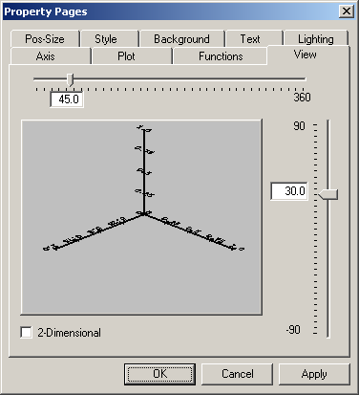
Figure 2 GSystems Graphic Control Properties - View Settings page
Object property pages are easily accessed in VB by pressing F4 when the appropriate object is selected.
There are many properties that can be set in the development environment. This is, of course, true for the run-time environment as well. Typically, you will set the properties in the development environment that represent the state of the control that is to be “constant” within your application. While, at run time, you set properties that vary depending on other contextual information, such as the desires expressed by the user through their manipulation of the system.
Note that you can even bring up the properties of the GSystems Graphic Control at run-time using the Properties() method.
All of the properties and methods available on the GSystems Graphic Control are detailed in Part III (page 11) and Part IV (page 27), respectively.

Part II – A step by step approach to getting results quickly
This section will help you to quickly get results using the GSystems Graphics Control in its default state, i.e., without setting a lot of the properties, or using many of the methods that manipulate the control.
Note: The next two sections provide listings of all of the properties and methods associated with the control. If it helps, you could skim that material now, looking at all of the names of the properties and methods. Then, as you work through this section, you might see places where some of these properties or methods would be useful.
We refer throughout this process to the GraphicSample.vbp Visual Basic sample shipped with the GSystems Graphic Control. If you need a new copy of this sample, you are welcome to download it from www.innovisionate.com.
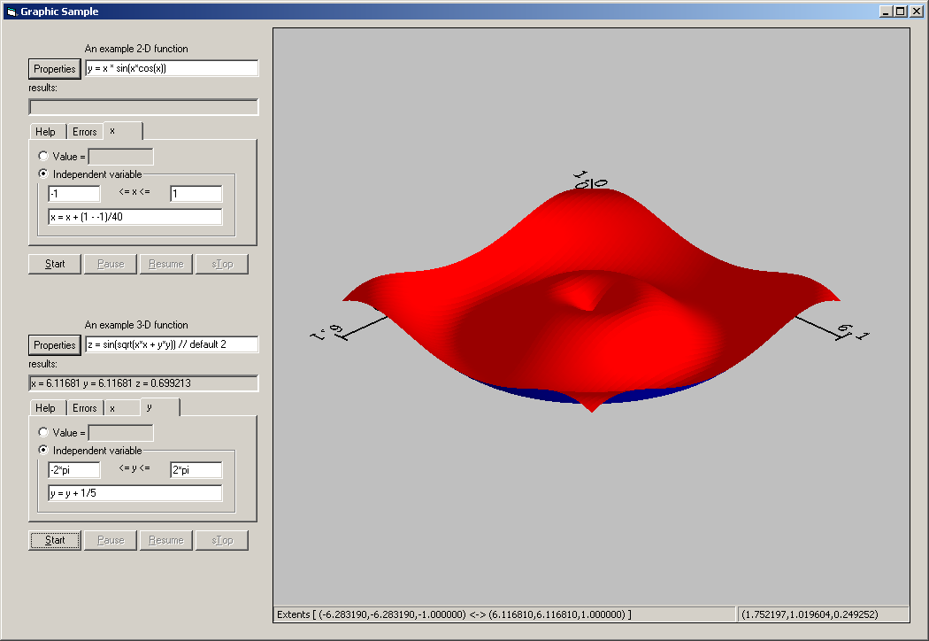
Figure 3 The Graphic Sample Visual Basic application
Note that this sample contains a 3 dimensional surface that was generated using the GSystems FunctioNater Control and specified with the function:
z = sin(sqrt(x*x + y*y))
This particular graphic was generated without having set any properties of the Graphic Control.
To accomplish this example, the instance of the GSystems FunctioNater control in the lower left – named GS3Dfunction - had it’s “Started” event caught by the Visual Basic code:
Private Sub GS3DFunction_Started( _
ByVal cntExpectedResults As Long)
GSystemGraphic.PrepareForData 0
End Sub
In this case, the GSystems Graphic Control was named GSystemGraphic on the form.
When the FunctioNater control sent the Started event to the Visual Basic application, the code implemented in the event handler called PrepareForData() on the GSystems Graphic Control – telling the control to reset itself and get ready to receive data.
Now, every time the FunctioNater control sends a TakeResults event to the VB application, the handler for that event passes the string containing data on to the GSystems Graphic Control:
Private Sub GS3DFunction_TakeResults( _
ByVal iterationNo As Long, _
ByVal bstrResults As String)
GSystemGraphic.TakeDataString bstrResults, 0
End Sub
And, finally, when the FunctioNater control sends the Finished event, the handler notifies the GSystems Graphic Control that it has received all of the data it will receive and that it can now draw itself:
Private Sub GS3DFunction_Finished()
GSystemGraphic.FinishedWithData 0
GSystemGraphic.Draw 0
End Sub
As mentioned above, all of the properties of the GSystems Graphic Control are in their default state as this graphic was drawn. To change the appearance of the graphic either the application developer, or the application user (or both) may set these properties to achieve a wide range of different results.
To see this in action, right click on the graphic above and you will find the system brings up context sensitive menus. The “context” in this case is whatever is under the mouse at the point where the user right clicks. For example, right clicking with the mouse over one of the axiis shows the “axis” menu from which you can set the properties of the particular axis near the mouse.
Note that the system draws a box at the mouse position when it detects that some object is near the mouse cursor.
If there is no particular object under the mouse when the user right-clicks, then the system will show the menu for the entire Graphic Control. From this menu, all of the properties of the Graphic Control itself may be set (see Figure 2) – including the properties of sub-objects on the Graphic Control (plots, etc.).
It is that simple to get results quickly using the GSystems Graphic Control:
- Paste the control onto a form
- Initialize the control (prepare it for data) from your code
- Send the control data as it is generated
- Tell the control it has all of it’s data and to draw itself
Even though it is this easy to get your graphic started, there are a great many properties with which to manage the look and feel of your graphic. These properties are described in the next section.

Part III – The GSystems Graphic Control Properties
This section describes all of the properties that control the look and behavior of the Graphic Control. Note that there are a great many properties and so they are presented here in a loose classification based on the following table.
Data  Page 15 | These properties control what type of “data” the GSystems Graphic Control should expect. Generally, the control will detect 2-D or 3-D data and act appropriately – however, sometimes you need to override the control if it has detected 3-D data when you are really sending it 2-D data with two dependent variables.
View  Page 15 | These properties control how the graphic will “look”, for example, from what vantage point the user will be view the data and the usage of lights to illuminate the scene.
Other objects  Page 21 | These properties will return other “objects” that have a rich set of properties in their own right. For example, the “X_Axis” property returns a reference to an axis object through which you can set the properties of the X axis. Other objects includes Axiis, Functions, Text, and Plots. Each of these has a set of properties and methods that are described in their own appendix of this document.
Other properties  Page 25 | These properties do not fit into any other classification.

About COM Properties
A short discussion is in order about COM properties that should help explain some of the differences that properties settings are accomplished in different development environments.
At the heart of COM properties on any ActiveX (or really COM) object is the fact that the object is providing a method that clients “call” to achieve the property setting. Sometimes this fact is hidden within a development environment because the environment is translating this “call” into what looks more like the setting of a variable – i.e., the property name might appear on the left side of an “=” sign.
Nevertheless, what is actually occurring is that these assignment statements are really getting translated into “calls” on the instance of the COM object.
Considering all of this, then, how do properties get set (or their values retrieved) when the development environment does not translate these settings into “calls” for you , for example, when you are writing in C or C++.
Simply put, you use the specially named methods that development environments would have translated these “settings” into anyway.
The convention used in this document to represent these methods is, by example:
{put | get}_UseStatusBar(
{VARIANT_BOOL| VARIANT_BOOL*} boolValue)
In the above, there are two methods represented, one is:
put_UseStatusBar (VARIANT_BOOL boolValue)
The other is:
get_UseStatusBar(VARIANT_BOOL* pboolValue)
And, in Visual Basic, and other environments which understand how to translate the calls into a more natural look, the syntax is:
gs.useStatusBar = boolValue
or,
boolValue = gs.useStatusBar
In this case, “gs” will be an instance of the GSystems Graphic Control. Also, the VARIANT_BOOL data type is an OLE true or false value; the same type which is a true or false value in Visual Basic.
This way, our syntax will describe both methods at once.
In this syntax, the “{ }“s with the “|” inside denote that one or the other of the items to either side of the “|” is to be included (of course, spaces would be removed where they cause syntax errors). Also, that if more than one of these appear in a single construct, then the same numerical order of selection made in the first group must be made in every other group as well.
When you see the argument is passing a pointer; when the data type is followed by * (which is passing ByRef in VB), you are generally expecting that the object will “return” a value to you (the caller) through this method. Visual Basic will deal with this appropriately if you use the standard assignment syntax as described above.
Occasionally, a single property name actually refers to a number of like items within the GSystems Graphic Control. For example, there are multiple lights available within the control and each light has a property indicating whether it is on or off. In such a situation, the syntax used to describe this property will be somewhat more complex in that you must specify which of the items the property applies to.
For example, to ensure that one of the 8 provided lights is turned on, you set the LightOn property. Here is the syntax we use to describe this property.
{put | get}_LightOn(
[in] long lightNumber,
{VARIANT_BOOL|VARIANT_BOOL *} enabled)
This syntax is stating that there is an additional argument, in this case a variable of type long, which provides some means to indicate which light (or other object as appropriate) is to be enabled. The “[in]” specification is just an indication that you need to supply a long value as input while the last specification in the argument list states that the property will return the result in this variable ( a ByRef variable in VB ).
Again, this extra information is only provided where ambiguity would otherwise result. One other thing to note is that the return value (or the “set to” value) is always the last argument provided.
In Visual Basic code, the following syntax is valid:
Dim isOn boolean
isOn = gs.lightOn(1)
gs.lightOn(1) = false
Again, “gs” is an instance of the Graphic Control and (1) denotes light # 1.
We also make the point that the number provided is from a 1-based numbering scheme, unless otherwise indicated. In other words, it is not the same as a typical VB array that starts at index 0.
Sometimes a “property” is really an array of values. For example, the position of the lights is specified in three values, X, Y, and Z. In this case, the “value” of the property will be a VARIANT. This variant can be an array of 3 values, i.e., 3 floating point measurements, or, it can be a simple comma delimited string that contains the specified values separated by commas. We make the distinction because when you want to retrieve the value of such a property, you must expect to retrieve it in a string variable. This is because Visual Basic cannot assign an array return value to an array. Other development environments may differ so your results may vary.
In any case, if you receive a compile or run-time error when you retrieve a GSystems Graphic Control property that has an array type value, try receiving that value into an explicitly Dim’ed “string” variable.
Dim strPosition as String
strPosition = gs.LightPosition(1)
And, as usual, gs is an instance of the Control. After the completion of this statement, the value of strPosition will contain 3 “values” separated by commas.
Note that if no put_... method is documented, then that “variable” may not appear on the left side of an ‘=’ statement. Assignment is not possible with such an item.

The GSystems Graphic Control Properties

Data Properties
The data properties control what “type” of data the Graphic Control should be expecting from the application. In general, this tells the control to expect 2-D or 3-Dimensional data. For example, if you send the following data to the control:
GSystemGraphic.TakeDataString “ 1.0, 1.0, 1.0”, 0
The control would likely determine that you are sending it an X, a Y, and a Z value (all with the value 1.0). If you had really intended to send the control an X and two Y values, you specifically need to set the control’s PlotType property:
GSystemGraphic.plotType = PLOT_TYPE_2D
Similarly, if you sent the following data to the control:
GSystemGraphic.TakeDataString “ 1.0, 1.0”, 0
You have only supplied 2 dimensions of data – if you want to show this in 3 dimensions (with a value of 0.0 for Z), you force the graphic into a 3-D state:
GSystemGraphic.plotType = PLOT_TYPE_3D
GSystemGraphic.plotSubType = PLOT_SUB_TYPE_NATURAL

Which will give you a curve on the X-Y plane at Z = 0.0.
{put | get}_PlotType ({long |long *} plotType)
This method switches between 2 and 3-D data. You should set (or expect the return value to be) one of the values:
PLOT_TYPE_2D
PLOT_TYPE_3D
Note that these two values are manifest constants defined in the GraphicControl_i.h file that will be installed wherever you install the control. This is useful if you are using a language such as C or C++. In an environment such as Visual Basic, these constants are known to VB through the Type Library that VB will “find” in the control itself – specifically embedded in the Graphic.ocx file. If you press F2 in VB, you can navigate to “Graphic” in the Object Browser and you will see these constants there.
{put|get}_PlotSubType(
{long |long *} plotSubType)
This property usually sets the “type” of 3-D graphic to show, however, there are a few 2-D graphics sub-types you can use. There is a rich set of sub-plot types as shown in the following table:
2-D sub-types
natural | This is the default type of sub-type. Note the sample is simply a cross-section of the 3-D samples shown. | 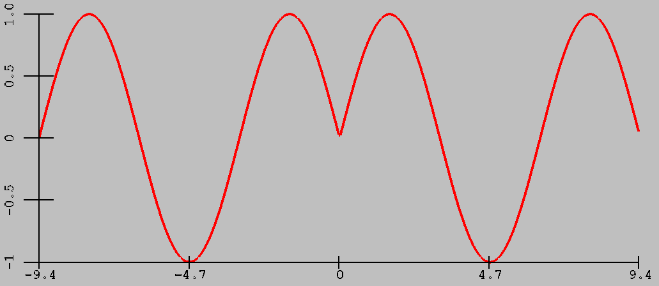
3-D sub-types
natural | Data is drawn using the X,Y, and Z data as it was received, from start to finish. Use this sub-type when you want to display 2-D data in a 3-D view. | 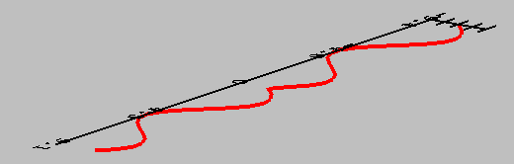
Wireframe | Data is “sorted” so that many curves are drawn, one for each distinct X-value in the data and one for each Y-value. Works best when the data is regular. | 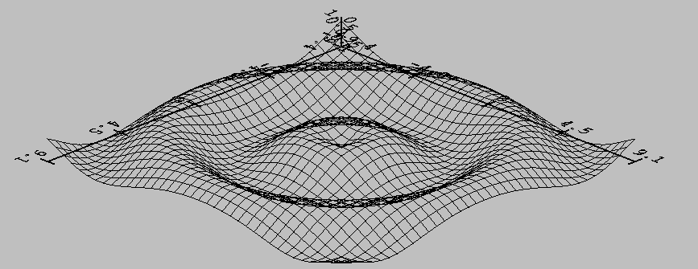
Surface | Very similar to a wireframe except that each “quad” of data becomes a small surface unit. This type can take advantage of the lighting capabilities. Again, works best when the data is regularly spaced. | 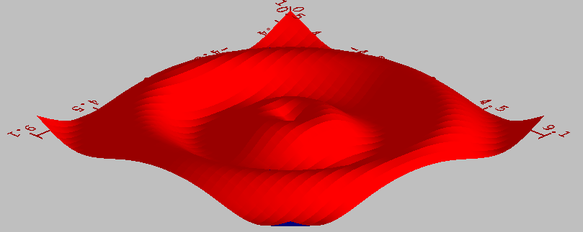
Stacks | Not ready for prime time
To set the value to use as the default Z value (as when Z is not provided in data sent to the Graphic Control), set the BaselineZ property:
{put|get}_BaselineZ (
{double |double *} baselineZ)

View Properties
These properties set how a 3 dimensional graphic will look. Specifically, how the graphic is rotated in space.
The position of the “viewer” with respect to the data is measured in terms of three angles.
The first of these, the θ (theta) angle, is an angle of rotation about the Z-axis that the viewer will travel to get to the viewing position. It is as if the viewer has walked θ degrees around the view in a direction that keeps the Z axis to the left. The minimum value of θ is 0.0, while the maximum value is 360.0.
The second “view” angle is called ϕ (phi) and refers to the “height” the viewer is from the X-Y plane. This value can be set from –90.0, to look directly onto the bottom of the graphic, to 90.0, to look directly down from the top.
Finally, there is a third angle that specifies a “spin” which should occur about the axis from the viewer (a position dictated by the other two angles) to the origin. This rotation causes the direction of “up” to point in different directions and will “tilt” the view accordingly.
There is a user-interface component in the property pages that you can use to explore the effects of each of these two angle settings.
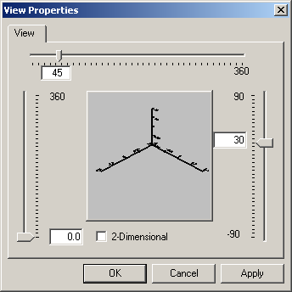
Figure 4 Setting the View
In this dialog, one sets the angle θ with the horizontal slider control along the top, and the ϕ using the vertical control to the right. Finally, to achieve a rotation of the whole coordinate frame as if the rotation were in the plane of the screen, exercise the slider to the left side of the window. To change these angles from within an application, use the following property settings

ViewTheta
{put | get}_ViewTheta(
{double |double *} viewTheta)
Changes (or retrieves) the θ angle (default value = 45.0), and,

ViewPhi
{put | get}_ViewPhi(
{double |double *} viewPhi)
sets or retrieves the ϕ angle (default value = 30.0), and,

ViewSpin
{put | get}_ViewSpin(
{double |double *} viewSpin)
sets or retrieves the final rotation in the plane of the screen.

Lighting Properties
The lighting properties control how the image looks when light shines on the object. In general, the effects of lighting are most pronounced when the graphic is showing a surface graph. Any graphic that has surface planes defined (a Stacks graphic is another example), can use lighting effects.
For the purposes of lighting, the GSystems Graphics Control provides 8 distinct light sources. You specify the location of each of these light sources (in the same coordinate system in which you supply your data) in 3-D space. You can turn each of these lights on or off, i.e., you do not have to use every light. For the light sources that you would like to use, you provide information on the position and the characteristics of three types of light the light source produces.
Ambient light is a kind of light that “bathes’ the scene. In the real world, this is the lower intensity light that appears to have no direct “source” because it reflects off of surrounding objects. This type of light has no discernable “direction” from which it is shining.
Specular light is a type of light that has a direction and intensity. Such a light will reflect off of shiny surfaces in a way that creates a bright spot on that surface. In particular, the reflection off a shiny surface is in a “preferred” direction that causes that surface to exhibit a more pronounced and sharper reflection. A piece of colored plastic, or a hand-rubbed apple, are good examples of specular light reflection.
Diffuse light is like specular light in that it has a discernable source. However, when this light is reflected off of most surfaces, it does so in a wider pattern so that the reflected “spot” contains much less distinct edges than with specular lighting.
Note that the interaction of these three types of light will change the graphic in dramatic and complex ways. For example, a high intensity of the light types will “wash” out the graphic as too much ambient or diffuse light will cause your graphic to loose shadows and/or contrast. The correct positioning and characterization of the light sources may take some practice to get the result you are seeking.
When you specify the color settings for one of these types of lights, you specify 3 values between 0.0 and 1.0. These three values are the Red, Green, and Blue (RGB) components of the light respectively. The value of each of these determines the intensity of the related light color in the whole. For example, if the Red component is 1.0, then the ultimately created color uses a full amount of Red in the mix. If G and B were both 0.0 the color would be a pure and intense red. However, if G is 1.0 and B is 0.0 (R being 1.0), the color is a mix of pure red and pure green, or, the color yellow.
Note that the color a graphic appears to be will depend on the amount of red, green, and blue light available (for it to reflect), and how much of each type of these colors the material reflects. For example, if you have a pure blue object, it will appear black in any light that does not have a blue component. A red or green light , for example, because a blue object does not reflect any red or green components of the light.
In order to minimize this interaction of the light with the material color, you can always include at least some component of each value (R,G, and B) in the light’s color specification.

The lighting properties

LightOn
To enable any one of the 8 lights provided by the system, pass true to the LightOn property. Note that light #1 is on by default, all others are off. Having turned the associated light on, don’t forget to position the light and to specify it’s light color properties.
{put | get}_LightOn(
[in] long lightNumber,
{VARIANT_BOOL|VARIANT_BOOL *} bOn)

LightPosition
To set the position of any light, in the same coordinate system (and domain) as the data you have sent to the Graphic Control, pass the X,Y, and Z position as either an array of three string values, a string containing a comma separated list of 3 values, or an array of real (or double) values, as follows.
{put | get}_LightPosition(
[in] long lightNumber,
{VARIANT | VARIANT *} position)
Again, the setting for this property is either an array or a string value containing a comma delimited list of values.
Note, however, that the retrieval form of the property will not work to assign to an array in Visual Basic. For example,
Dim lightPosition(2) as Double
lightPosition = gs.lightPosition(1)
The above code will fail because VB is not able to assign the array value. However, the slightly different,
Dim lightPosition as String
lightPosition = gs.lightPosition(1)
does work because VB can assign the returned value as a comma delimited string of values. We also note from this exercise that the default lower bound of a VB array is 0, so that the array dimensioned above goes from 0:2 – containing 3 elements.
We repeat an example shown before because it is pertinent to this discussion.
Dim lightPos(2) as String
lightPos(0) = “MinX + (MaxX – MinX)/2.0”
lightPost(1) = “MaxY”
lightPos(2) = “MinZ + (MaxZ – MinZ)/2.0”
gs.lightPos(3) = lightPos
This example uses string expressions to place the 3rd light at a point in the middle of the X-domain, at the end of the Y-domain, and at the middle of the Z-domain. Such a light shines onto the mid-section of the graphic from the “Y” side. This was specified without having to know the actual extents of the data used in the graphic.
The next 3 properties are very similar to the position property in that the “value” is an array of three values. In this case, however, the properties expect to receive a simple array of real variables. Also, the value of the variables in these arrays should be between 0.0 and 1.0 inclusive.
These three properties are introduced and then discussed.

AmbientLight
{put | get}_AmbientLight (
[in] long lightNumber,
{VARIANT | VARIANT *} RGB_Triplet)

DiffuseLight
{put | get}_DiffuseLight (
[in] long lightNumber,
{VARIANT | VARIANT *} RGB_Triplet)

SpecularLight
{put | get}_SpecularLight (
[in] long lightNumber,
{VARIANT | VARIANT *} RGB_Triplet)
These three “types” of light were discussed in detail on page 19. Here the discussion will center on how to use the properties.
To set the value of one of these properties, you need to dimension an array in VB, set the values of the array, and then set the property to that array.
For example,
Dim ambientLight(2) as Double
ambientLight(0) = 0.5
ambientLight(1) = 0.5
ambientLight(2) = 0.5
gs.ambientLight(1) = ambientLight
which provides a Red, Green, and Blue component of the ambient light of 0.5. Note that this color is a shade of gray. Any light specification where the three values are equal will be a shade of gray. The color is black where the values are 0.0 ranging to white with all values equal to 1.0. Essentially, this “gray” color in the ambient light is indicative of the intensity of the light, not the actual color. In other words, the light is not a gray light as much as it is a “half of pure white” light.
Note that to retrieve the current value of the property, you need to dimension a variable as a String variable and set that variable equal to the property.
Dim specularLight as String
specularLight = gs.specularLight(1)

If you look at the value of this string, you would find it might contain, as an example, the value:
“0.5,0.5,0.5”
which is a value you can parse for the numerical values if you need them.
All three of the light properties operate in the same way, they differ only in name. Though the effect of each type of lighting is different, as described on page 19.

Other Objects
During the construction of the GSystems Graphic Control’s representation, there will be other objects over whose appearance you will have full control.
Each of these objects has a rich set of it’s own properties and methods that you can utilize. The description of these are found within this document in the following places:
Object Is described in: Is described in:
An Axis object: There are typically 2 or 3 of these (for 2-D and 3-D graphics respectively), though there can be more created at run-time. These objects depict the “domain” of any given dimension. That is, they show the user the minimum and maximum value of the dimension.
Appendix B
A Plot object: A graphic will be comprised of at least one but as many as desired “plot” objects. These are the actual representation of any one of the data sets that the Graphic Control will display. These objects may be thought of as the individual “lines” on the Graphic.
Appendix B
A Function object: One of the ways to provide data to the graphic is to define and use one or more “functions” on the graphic. These are instances of the GSystems FunctioNater Control that is built-in to the GSystems Graphic Control. Through user or application control, one ore more of these functions can be created and the properties and methods on each of these can be manipulated via the interface returned from this object property.
Appendix C
A Text object: Any text placed on the graphic, through either the user’s actions or your utilization of the Graphic Control’s methods, can be manipulated once you retrieve an reference to an interface on the text object.
Appendix D

Axis Object
There are three axiis objects at all times on the Graphic Control. At certain times, however, the Z axis may not be visible. This is when the view is looking directly at the X-Y plane and when the Z axis would be directly toward (or away) from the view – it is not drawn.

Axis
To retrieve an instance of an axis object, you must indicate which of the axiis to retrieve, i.e., X, Y, or Z.
get_Axis (
BSTR axisType, IDispatch **pDispatchAxis)
This call is an example of a “retrieve” only property, i.e., you cannot set the value of the property. The BSTR value is an OLE safe “string”. This is just a normal string value in Visual Basic.
A typical usage of this property in Visual Basic is:
Dim xAxis as Object
Set xAxis = GSystemGraphic.Axis(“X”)
xAxis.DrawText = false

which would tell the X-Axis not to draw its label text. Again, for more information about the axis object, refer to Appendix B.

Plot Object
The Plots on a Graphic are identified by their number. This number is generated as each plot is created. For example, plots are numbered from 1 to the number of plots.

Plot
Therefore, to retrieve an instance of a plot object, you need to provide its number.
get_Plot (
long plotNumber, IDispatch *pDispatchPlot)
To see the description of a plot object and all of its methods and properties, please refer to Appendix B.

Function Object
Every graphic may contain any number of instances of the GSystems FunctioNater object. This powerful object is able to generate 2 and 3-D data from any numerical function or expression that you define – over any range of x and y data values.

Function
When you need to obtain a reference to one of these objects, you must pass the expression of the function to the property. When there are more than one functions with the same expression, you must pass a # value at the end of this name.
get_Function (
BSTR functionExpression,
IDispatch *pDispatchPlot)

Again, if you have more than one function with a given expression, append a “# _” value to the end of the first argument.
Here is a VB example.
Dim f1 as Object
Dim f2 as Object
Set f1 = _
GSystemGraphic.Function(“z = cos(sqrt(x*x + y*y))”)
Set f2 = _
GSystemGraphic.Function(“z = cos(sqrt(x*x + y*y)) #2”)
f1.evaluate()
f2.evaluate()
You might have two functions with the same expression defined if, for example, you’d like to view the same function over different domains, i.e., ranges of the dependent variables x and y.

Text Object
Text may be placed on the Graphic either by your application calling methods that add text or by the user adding text through the context sensitive menu.
In either case, there is a rich set of attributes that may be set on the text object that control how the text draws. Including the 3-D position and direction of the text.

Text
To obtain a reference to the text object, you can use the Text property.
get_Text (BSTR text,
IDispatch *pDispatchPlot)
Here, we have to know the content of the text in order to retrieve the interface pointer to the appropriate one. As with the function expression, if you have multiple instances of text with the same “value”, you can pass a “#_” field on the end of the expression.

Other Properties

Part IV – The GSystems Graphic Control Methods

Appendix A – The Axis object
An axis is used to help you visually measure along one of the dimensions on a Gsystems Graphic Control graphic.
The axis will contain all of the information that will help the user understand the range of data in one dimension as well as some definition for what that data represents. This latter ability is reflected in the use of a “label” that annotates the data.
The GSystems Graphic Control always contains 3 axiis. When you have specified a 2 dimensional data representation, all three axiis still exist, however, the Z-Axis is not shown as it would point directly at the user. This is also true with 3 dimensional graphics where the “view” is looking directly at the X-Y plane. No other axis is hidden, however, if you are looking directly at some other plane.
You control the appearance of each axis by setting the properties described in this section. If you do this from a program, you would first obtain the desired axis “object” using the GSystems Graphic Control’s Axis property described on page 24.
Having obtained an object pointer, you can set it’s properties in Visual Basic as in the following example.
Dim axisObject as object
Set axisObject = gs.Axis(“X”)
axisObject.Label = “X-Axis”
where gs is a reference to the instance of the GSystems Graphic Control on the form.
If you allow the user to set the properties of the graphic at run-time (see DenyUserPropertySettings on page 32), they can choose one of the three axiis from the property dialogs and set these properties at run time.

The Axis Properties
The axis properties are grouped into two major sections; 1) those which deal with text and, 2) those which dictate the general “look” of the axis.

Axis Text Properties
These properties dictate how the text will be drawn along the axis. Typically, this text specifies the numerical range of the data provided to the graphic, each of these numbers is placed next to what is referred to as a “tick” - a mark that indicates precisely where on the axis the number refers - along the axis. However, it is possible to supply a series of text values that can be placed at these tick marks.
This would be done, for example, if your data was provided on a day of the week basis you could specify the labels be the name of each day rather than the number 1 through 7. Note that the data provided to the graphic control for representation would still need to be numeric. That is, the text labels provided in this manner are simply aliases for the actual numeric data value.

DrawText
{put | get}_DrawText(
{VARIANT_BOOL | VARIANT_BOOL * } drawText)
If you specify FALSE for this property, the system will not draw any text at each of the tick values on the axis. Note that drawing text may cause the general scaling of the graphic to change because the text itself participates in determining the actual domain of the data on the graphic. This domain, in turn, is used in the auto-scaling of the graphic to prevent any of the data from getting clipped and to show the graphic’s data in as large a view as possible given the size of the window in which it is displayed.

LabelText
This property sets the content of the text that appears in the middle of the axis and below it.
{put | get}_LabelText(
{BSTR | BSTR * } labelText)
Note that if this label is not provided, the Graphic Control will utilize the extra space and grow into it.

RepresentativeText
This property returns a reference to a text object that the axis owns and from which it provides the settings that dictate the behaviour of all of the tick label text objects.
get_RepresentativeText(IDispatch **pRText)
Simply put, to set the properties of the text that will be drawn at each of the tick labels, you retrieve this object and set the properties of it. When the text on the ticks is drawn, the properties of this object are applied to those objects.
Note the following technique will provide your users with a dialog through which they can manipulate these properties:
Dim axis as object
Dim rText as object
Set axis = gs.Axis(“X)
Set rText = axis.RepresentativeText
rText.EditProperties()
Again, gs is a reference to the GSystems Graphic Control. This example is allowing the user to set the properties of the text that appears along the X-Axis.
To set the properties for the entire axis (including the representative text), one would call:
Axis.EditProperties()
Rather than getting the text object and setting the properties on that.
Please refer to Appendix D for a full description of each of the properties that apply to text.

Appendix B

Appendix C

Appendix D

Epilogue
First, allow us to thank you for purchasing the GSystems Graphic Control and giving us a chance to help with your development efforts.
We never forget the privilege it is to be asked to join your team !
Though we try as best we can, it is inevitable that you might have discovered some bug in the tool or inconsistencies in its use with respect to this document.
In either case, we would very much like to hear from you if you’ve had any problems. Indeed, we appreciate any form of constructive criticism as well as any kudos you can provide as well.
One of the very important reasons for this is that there are so many environments, types of applications, and other factors within which our software may get used that we could not possibly have thought of all the features we needed to put in the system. Your assistance can help us to get any needed features and fixes into the product as soon as possible.
We would also like to know how well this manual has presented its material and if you think some other approach would have been more effective. We believe that proper technical documentation is something of a young and fledgling science and we don’t purport to be the best at it … yet!
With your help, however, we can get there.
Thanks again !
problems@innovisionate.com
ideas@innovisionate.com
support@innovisionate.com
Temporary link destinations:
PickBoxSize
PlotType
PlotSubType
DenyUserPropertySettings
PrepareForData

A “method” refers to a function which is furnished by the GSystems Graphic Control object. In other words, you “call” a method. A property, on the other hand, is a “state” of a part of the control. Usually, these can appear on the left side of an ‘=’ sign; it generally depends on the development environment.
All of this can be set to your own preferences.
There is a property you can set to specify this angle.
The size of this box is controlled by the PickBoxSize property of the Control. The default value is 5 pixels square.
You as application developer can prevent the Graphic Control from showing properties to the user of the application – for example, if you would like to retain full control of how the graphic should look to the end-user. See the DenyUserPropertySettings property setting.
Remember that a value may be an expression that uses system variables such as MinX. See the discussion on page 3.
Note that the BaselineZ property sets a value to use for the default Z value subsequent to it’s being set.
You should know that you need to “#include” GraphicControl_i.h in every source file that references methods or properties on the IGSGraphic interface and that you need to include GraphicControl_i.c (note the extension is “c”) in one and only one file in your project.
Meaning that there is some consistent “spacing” between the x and y values so that the system can find a set of values where one of X and Y are constant.
All angles are specified in degrees, not radians.
Why strings ? Remember that any numerical value needed by the GSystems Graphic Control can be provided as a string. This means that the values passed here (as strings) may contain variables and/or expressions involving the domain of the data set. See page 3 for more information.
If you have created a new axis, you must pass the one letter identifier you gave that axis when you created it.
See the property PlotType on page 32.
Note that the GSystems Properties Control may slightly adjust the range of the provided data if it can do so to arrive at a “cleaner” range. Cleaner means that fewer decimal points may be used to represent the numbers on the axis without loosing more than a specified precision in those numbers.
Below means on the other side of the tick labels from the data. This actual location depends on which axis as well as the orientation of the particular axis.
All GSystems Controls and their associated sub-objects have an EditProperties() method which works in similar fashion.

